Reg.Nr 40102021658

AS Norvik Banka, S.W.I.F.T. LV51LATB, LV51LATB0002010016602

Dzeļzceļa sprieguma invertori

CENRĀDIS 11.11.2014.g.

Invertori | Parametri | Daudzums | Mērvienība | Cena, EUR/gab.  t.sk. 21%PVN
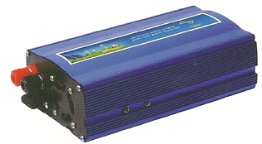  CZ-300S | 300W, 40-65VDC,  220VAC, 50 Hz.  Pure sine wave output | 1 | gab. | 250,00
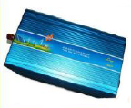  CZ-1000S | 1000W, 40-65VDC,  220VAC, 50 Hz.  Pure sine wave output | 1 | gab. | 510,00
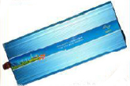  CZ-2000S | 2000W, 40-65VDC,  220VAC, 50 Hz.  Pure sine wave output | 1 | gab. | 910,00
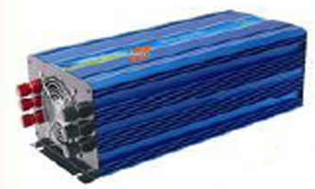  CZ-3000S | 3000W, 40-65VDC,  220VAC, 50 Hz.  Pure sine wave output | 1 | gab. | 1350,00
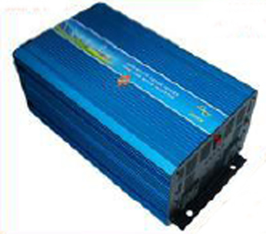  CZ-4000S | 4000W, 40-65VDC,  220VAC, 50 Hz.  Pure sine wave output | 1 | gab. | 1590,00
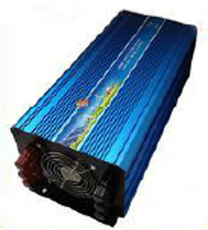  CZ-5000S | 5000W, 40-65VDC,  220VAC, 50 Hz.  Pure sine wave output | 1 | gab. | 1850,00
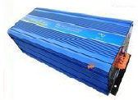  CZ-6000S | 6000W, 40-65VDC,  220VAC, 50 Hz.  Pure sine wave output | 1 | gab. | 2050,00

Pazinojums: Kontakta persona:
Garantijas laiks – 1.gads. Jevgēnijs Sidorovs
Vairumtirdzniecības atlaide: 5% (ar vairak neka 10.gab.) e-mail: evgeny@ufo.lv
Piegādes laiks - 20. d no priekšapmaksas dienas. skype: ufolats
m.t. +0037129493141

